Computer Language Coding Concepts

Parameters in a Command Call in a Diagram
Parameters in a command call have been conceptually explained in the article Parameters in a Command Call.

This article only illustrates how parameters in a command call look in a diagram.

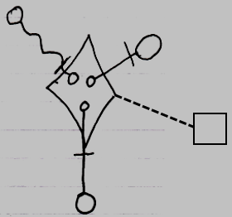

The diamond shape is a command call. What makes it a command call, is that it is tied to its command definition, the square, with a class line, the dashed line. The circles inside the diamond are the parameters. The parameters are tied to objects on the outside with parameter passings. The parameter passings are the lines connecting the smaller circles, the parameters, to the larger circles ouside the diamond. Parameter passings are explained later in the parameter articles.

The creation behavior of parameters in a command call will not be further explained with diagrams in this article. Refer to the article Creation Behavior of Command Callls in a Diagram for an illustration of how the creation behavior of command calls looks in a diagram.

See also: Parameters in a Command Call,
Creation Behavior of Command Calls in a Diagram

Author & Copyright: Jan-Joost van Zon Date: August 9, 2008 – August 9, 2008 Location: Oosterhout, The Netherlands Status: Finished

